Experiment 38: Face Detection using OpenCV
Software / Tools: Python · OpenCV (cv2)

AIM
To detect human faces in an image using OpenCV's Haar Cascade Classifier.
ALGORITHM
1. Import OpenCV.
2. Read the input image and convert it to grayscale.
3. Load a pre-trained Haar Cascade classifier for frontal face detection (bundled with OpenCV at cv2.data.haarcascades).
4. Call detectMultiScale() on the grayscale image to get bounding boxes of detected faces.
5. Draw a rectangle around each detected face using cv2.rectangle().
6. Display and save the output image with faces marked.
PROGRAM (SOURCE CODE)
import cv2

img = cv2.imread("person.jpg")
gray = cv2.cvtColor(img, cv2.COLOR_BGR2GRAY)

# Load pre-trained Haar Cascade for face detection
face_cascade = cv2.CascadeClassifier(
cv2.data.haarcascades + "haarcascade_frontalface_default.xml")

faces = face_cascade.detectMultiScale(gray, scaleFactor=1.1, minNeighbors=5, minSize=(40, 40))

for (x, y, w, h) in faces:
cv2.rectangle(img, (x, y), (x + w, y + h), (0, 255, 0), 3)
cv2.putText(img, "Face", (x, y - 10), cv2.FONT_HERSHEY_SIMPLEX, 0.7, (0, 255, 0), 2)

cv2.imshow("Face Detection", img)
cv2.waitKey(0)
cv2.destroyAllWindows()

OUTPUT
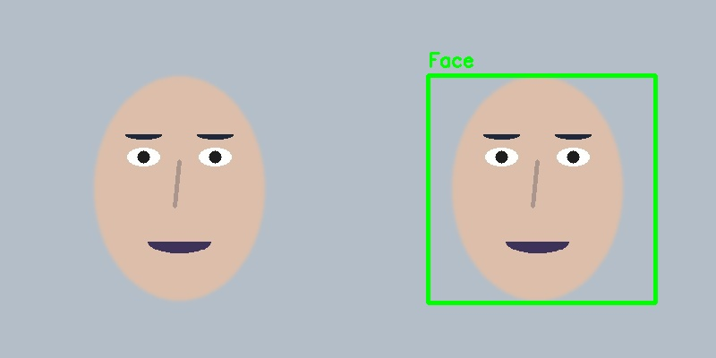
Fig. 38 — Output of Experiment 38: Face Detection using OpenCV.
RESULT
Detect human faces in an image using OpenCV's Haar Cascade Classifier — completed successfully, as demonstrated in the output shown above.

